МИНИСТЕРСТВО НАУКИ И ВЫСШЕГО ОБРАЗОВАНИЯ  
РОССИЙСКОЙ ФЕДЕРАЦИИ

федеральное государственное автономное   
образовательное учреждение высшего образования  
«Самарский национальный исследовательский университет   
имени академика С.П. Королева»

(Самарский университет)

Институт информатики и кибернетики

Кафедра технической кибернетики

**Отчет по лабораторной работе №3**

Дисциплина: «Развертывание и жизненный цикл программного обеспечения»

Тема: **«Building a CI/CD Pipeline.Ansible»**

Выполнил: Дубман Л.Б.

Группа: 6133-010402D

Самара 2023

**Задание**

Шаги:

1. Setup artifact manager tool, e.g. Nexus OSS, JFrox Artifactory free tier
2. Setup Ansible instance
3. Setup Jenkins “Publish over SSH” plugin to send JAR to Ansible server
4. (+0.5pts) Set Ansible playbook to create Docker image based on JAR and push image to DockerHub
5. (+0.5pts) Setup Jenkins-Nexus integration to send JAR to Nexus server. Modify Ansible playbook to create Docker image based on JAR grabbed from Nexus, modify playbook to send final Docker image to Nexus.
6. Add screenshot of JAR pushed to Nexus/Artifactory (if you made step 5) or Docker image pushed to DockerHub

**Ход работы**

Install nexus:

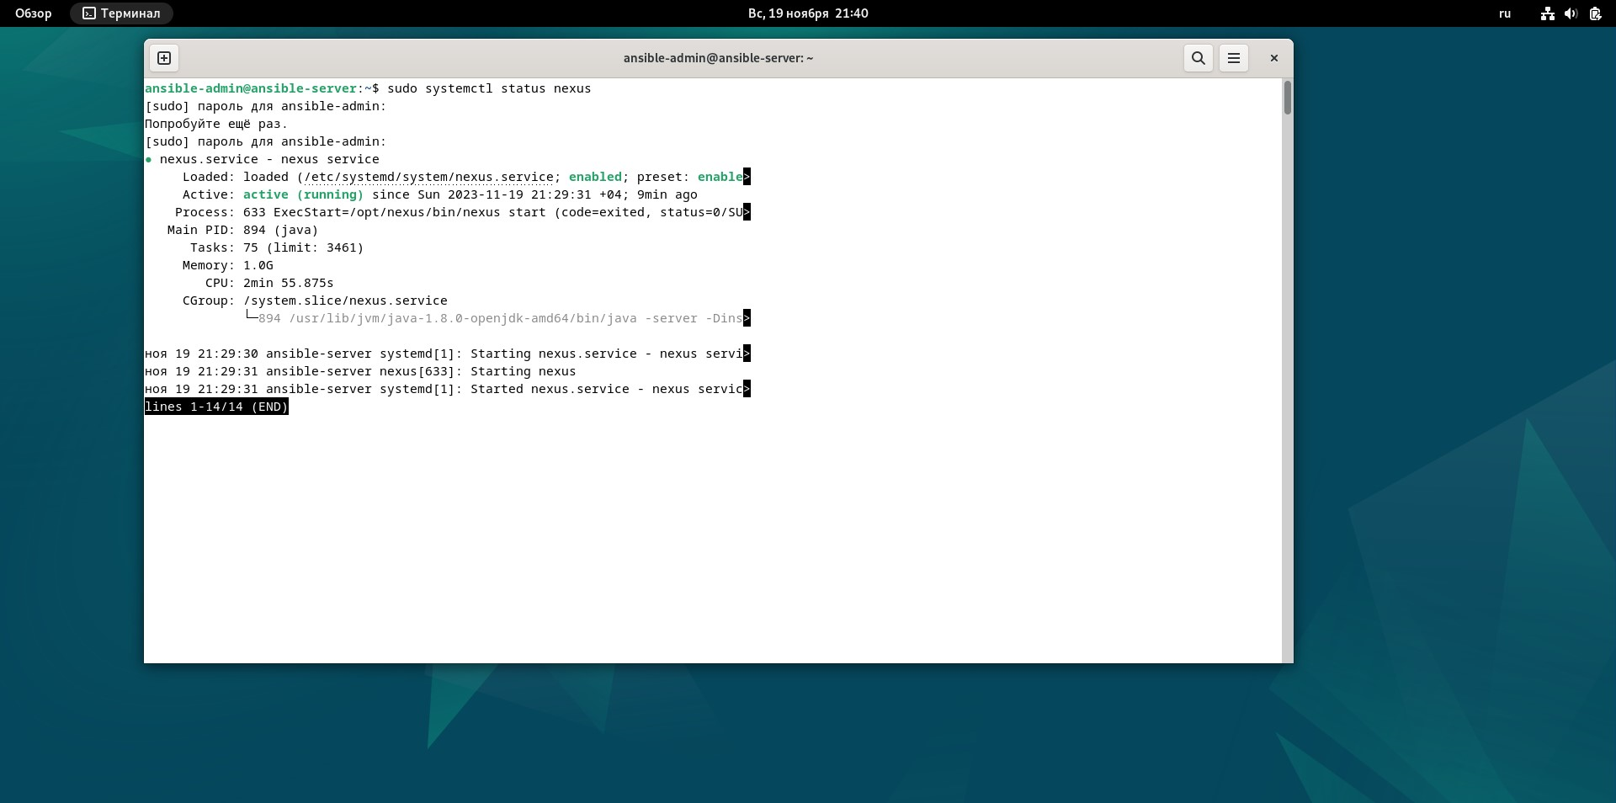

Change the hostname of “AnsibleServer”:

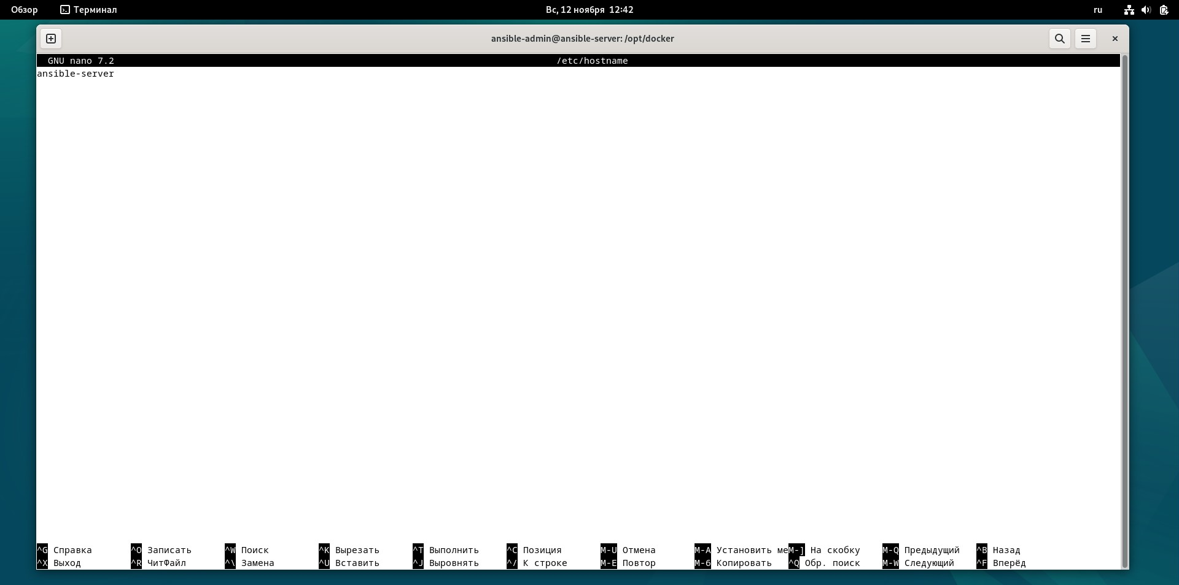

Configure user privileges by editing the sudoers file:

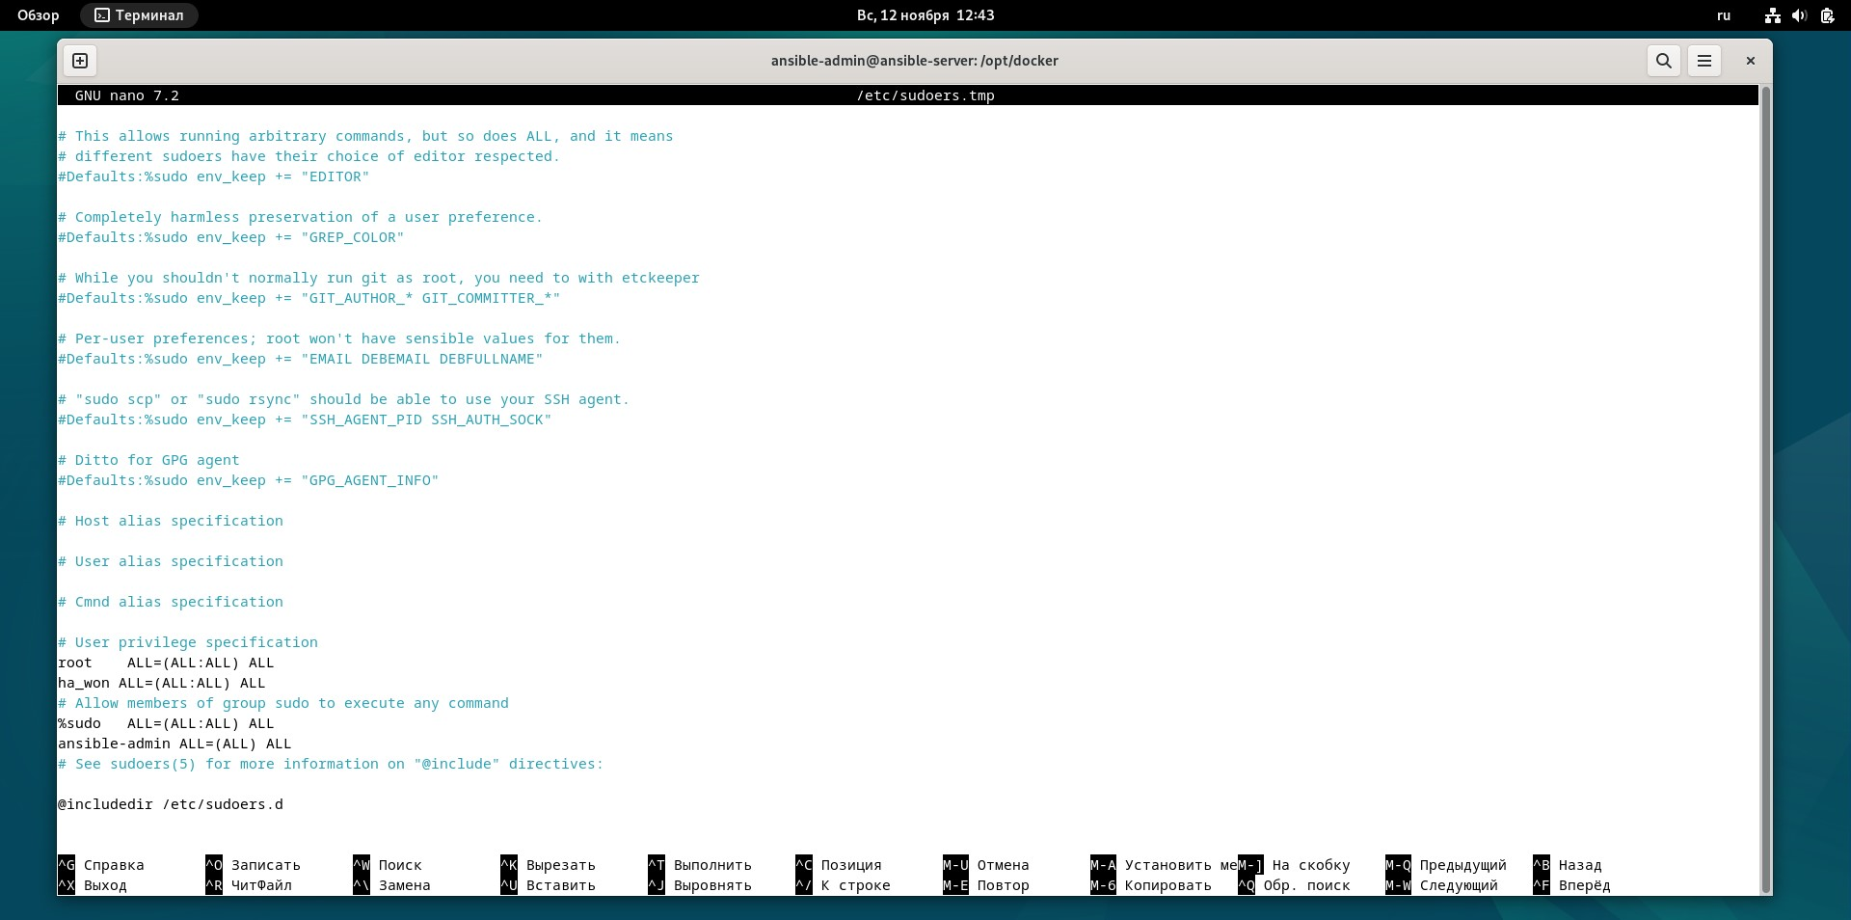

Edit /etc/ssh/sshd_config file to enable PasswordAuthentication:

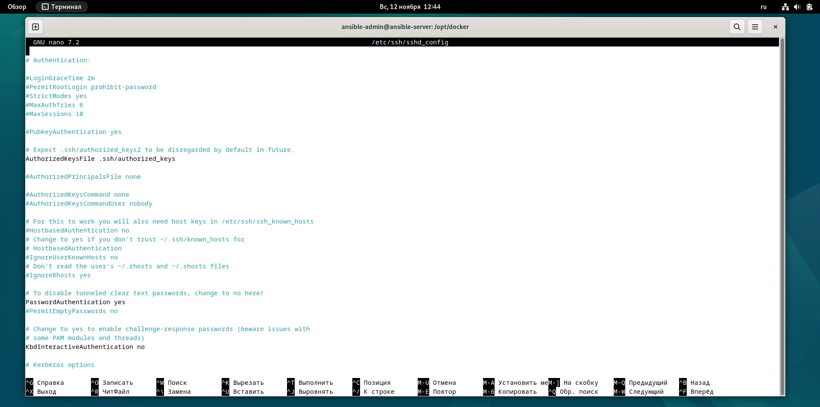

Install Ansible:

ansible –version

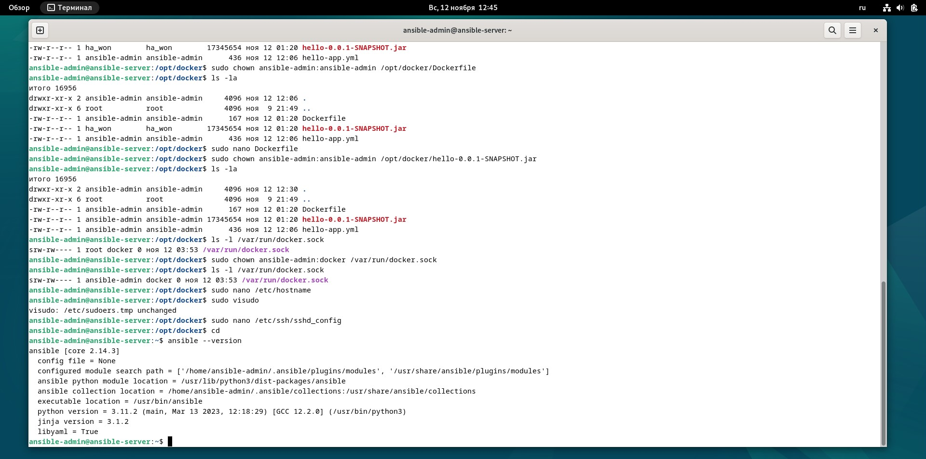

Install and configure Jenkins “Publish over SSH“ plugin on JenkinsServer

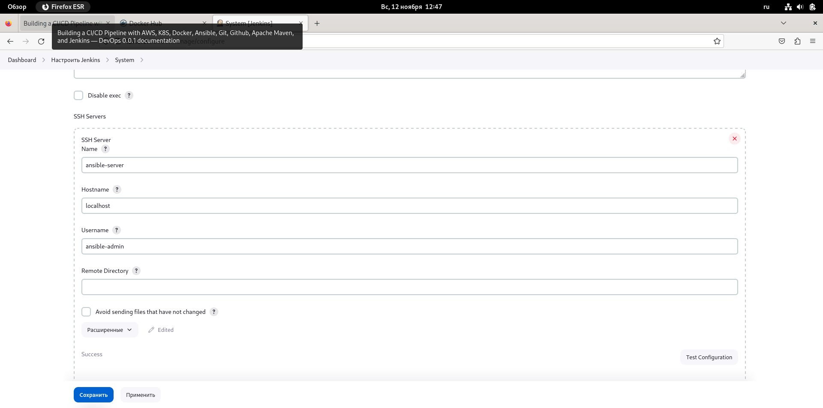

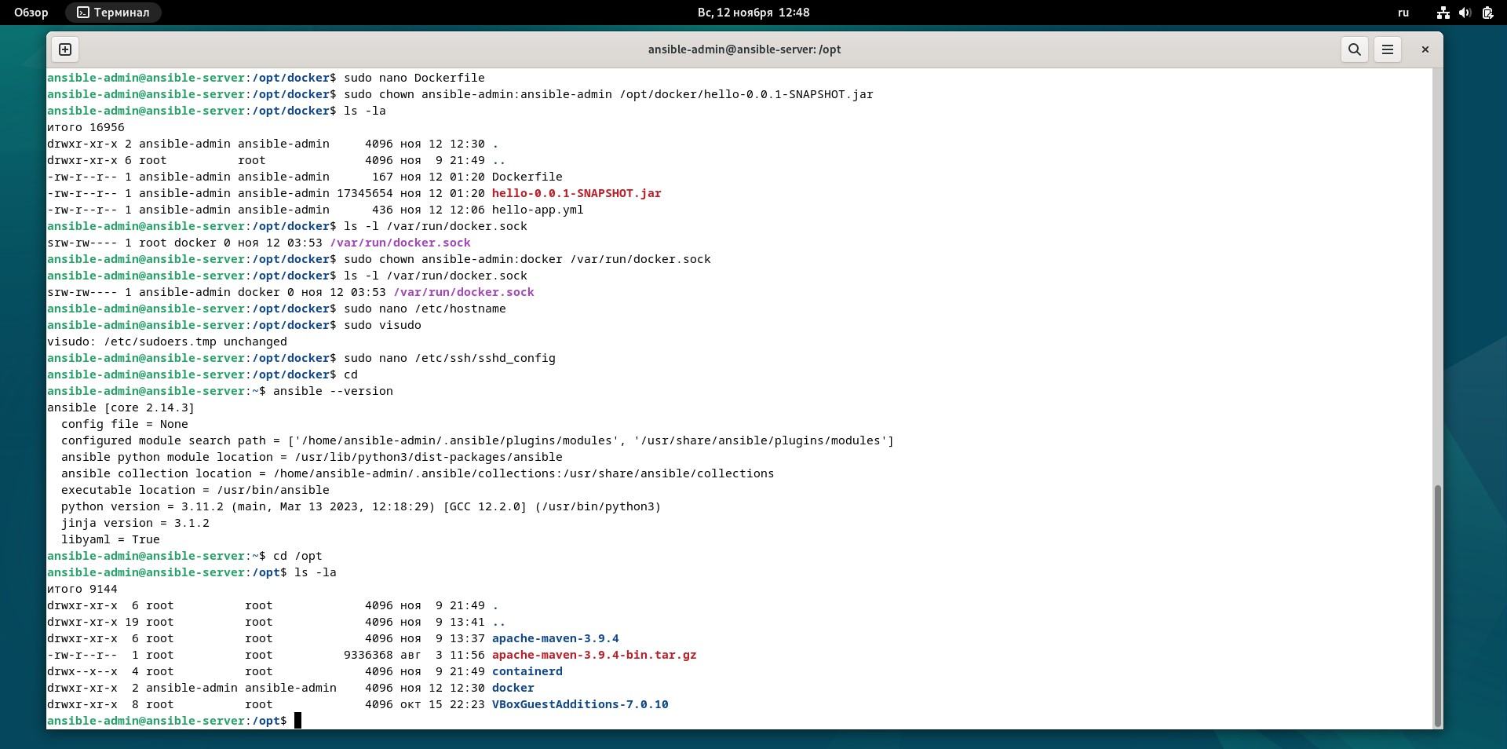

Integrate “Publish over SSH“ Github plugin into the pipeline:

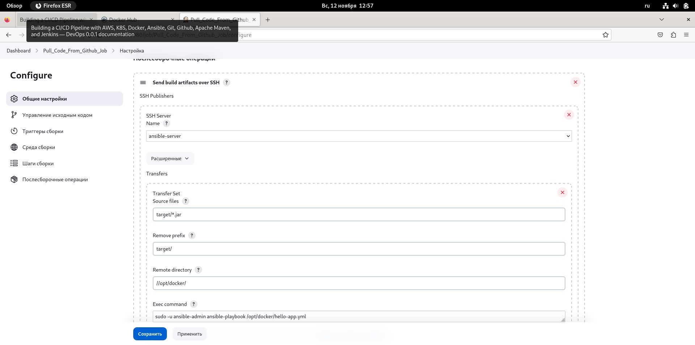

Test “Publish over SSH“ Github plugin integrated into the pipeline:

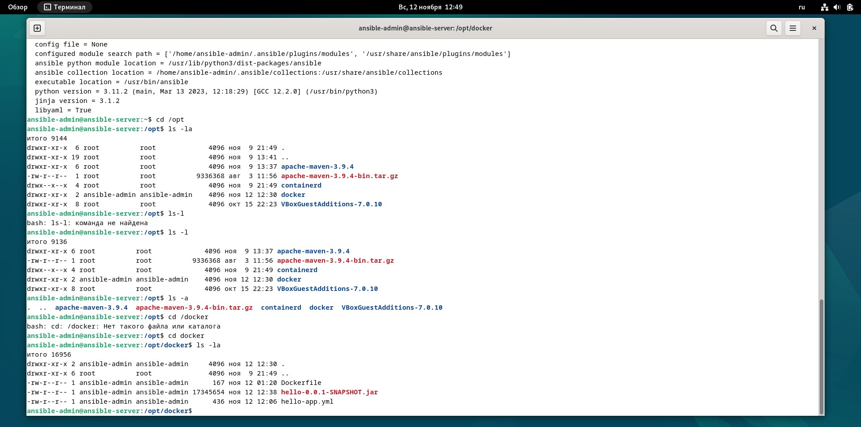

Configure Ansible hosts:

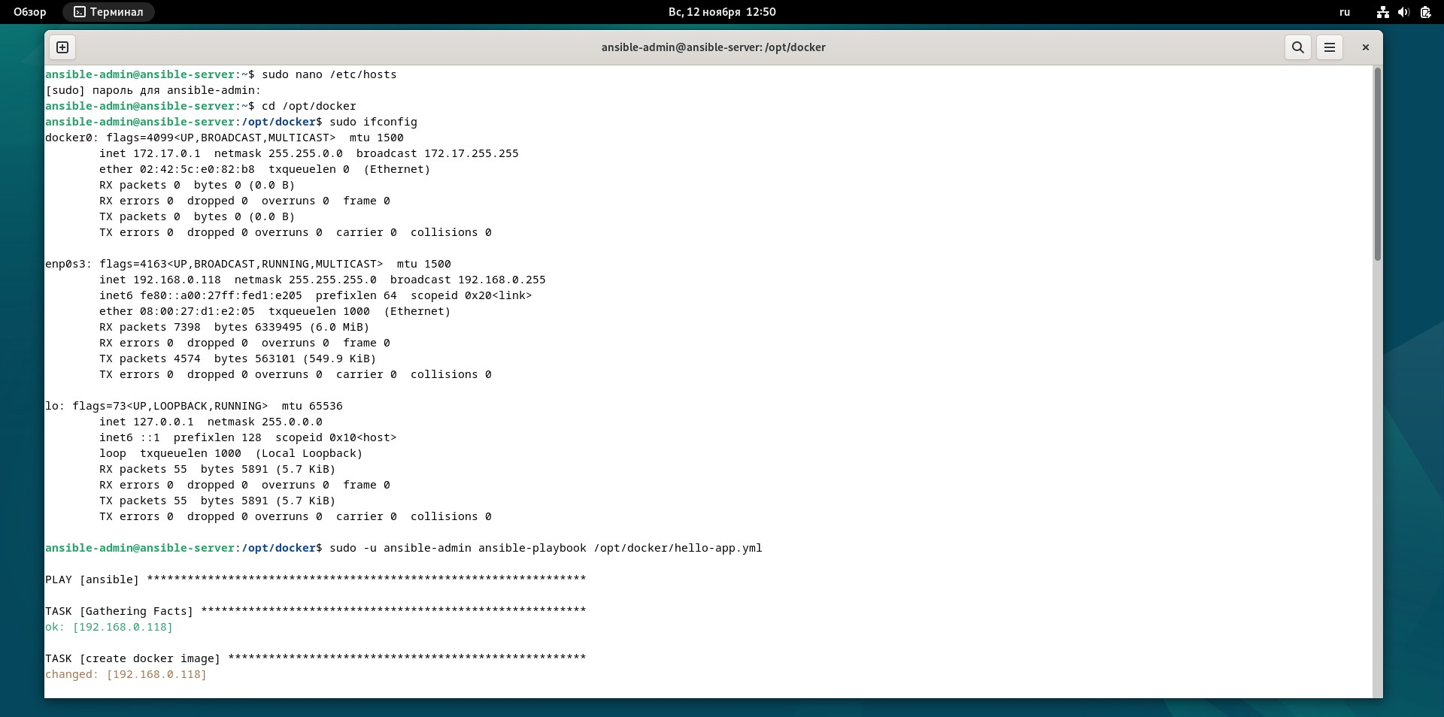

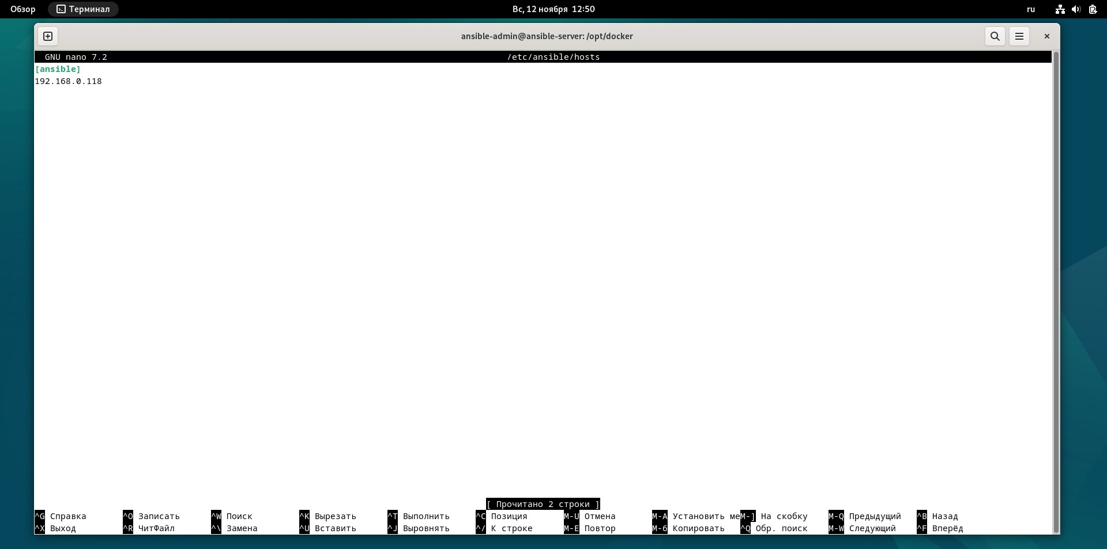

Configure Passwordless SSH authentication to localhost for Ansible and reate a new Ansible playbook for Docker tasks:

inside the file, type in the following stuff

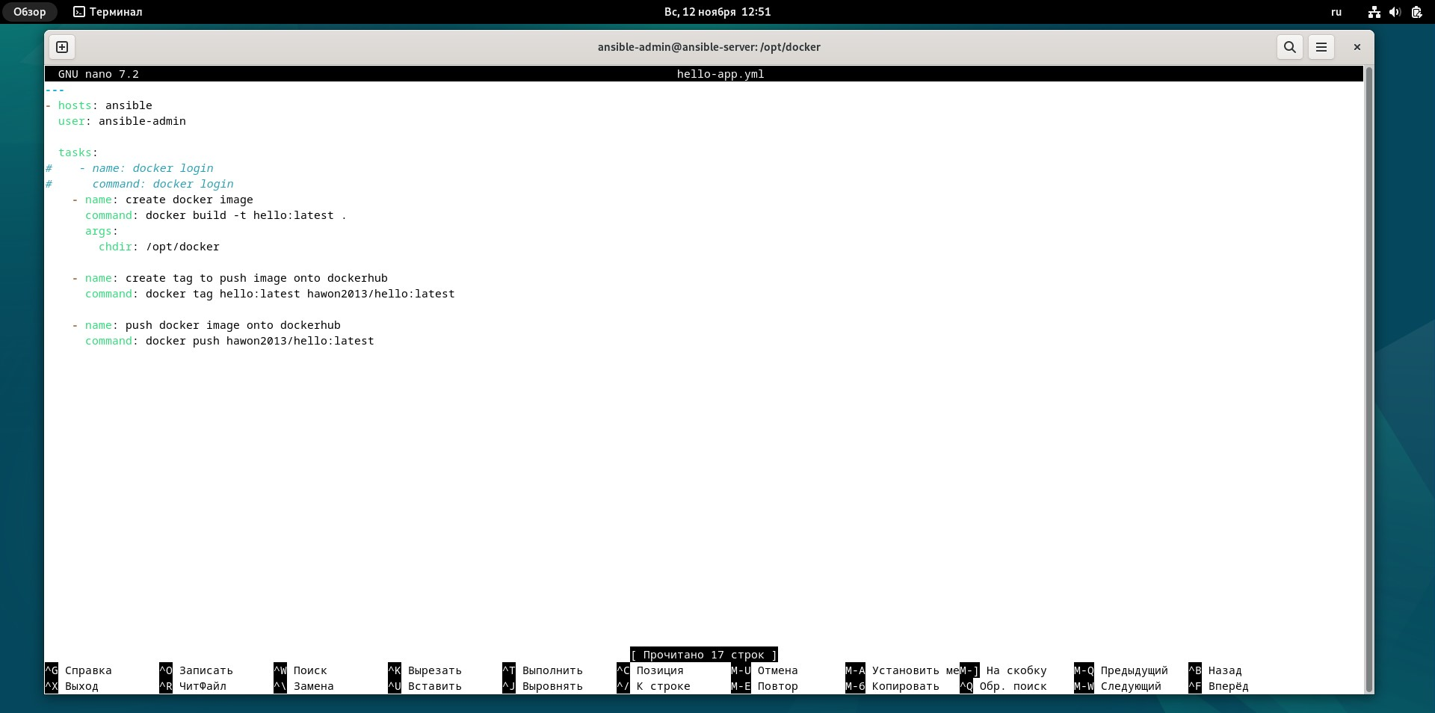

Test the Ansible playbook with Docker tasks:

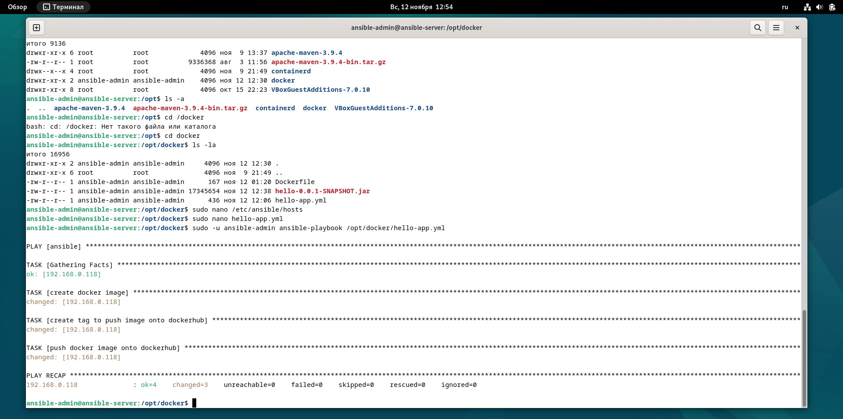

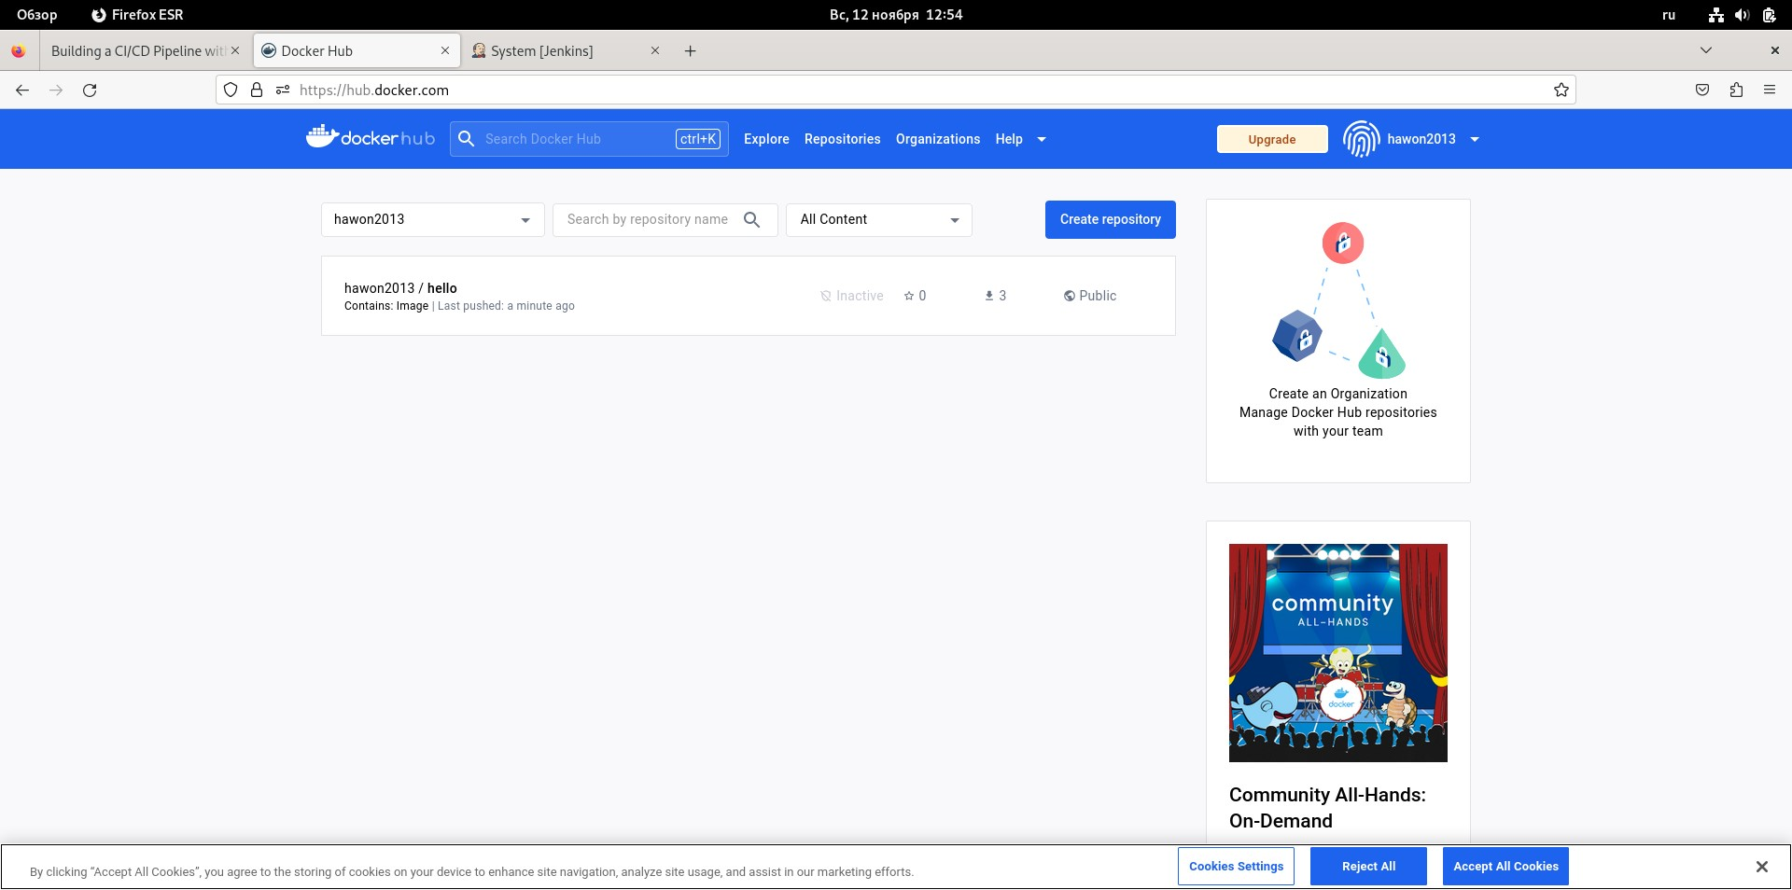

Integrate Ansible Docker tasks into the pipeline:

Test “Ansible playbook with Docker tasks“ integrated into the pipeline:

